Q1: simple code to use module with functions (No Passing Arguments to Functions).

# This program demonstrates a function.

# First, we define a function named message.

def message():

print('I am Arthur,')

print('King of the Britons.')

# Call this function

message()

After you get this program to successfully run, capture its output and then close it!

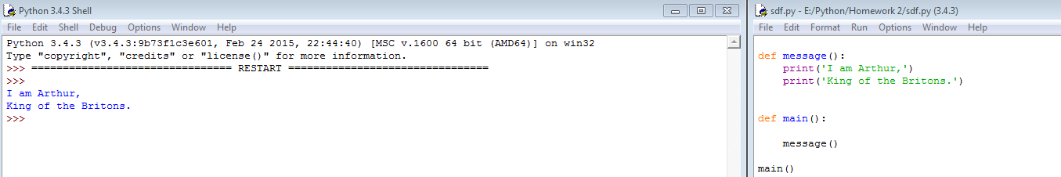

Q2: simple code to use module with functions (Passing Arguments to Functions).

# Define the main function.

def main():

number = int(input('Enter a number and I will display that number doubled: '))

double_number(______________________) # call this function

# Define the double_number function.

def double_number(_________________________):

result = value * 2

print(result)

# Call the main function.

main()

Fill in the above empty place, and the debug this code. After you get this program to successfully run, capture its output and then close it.

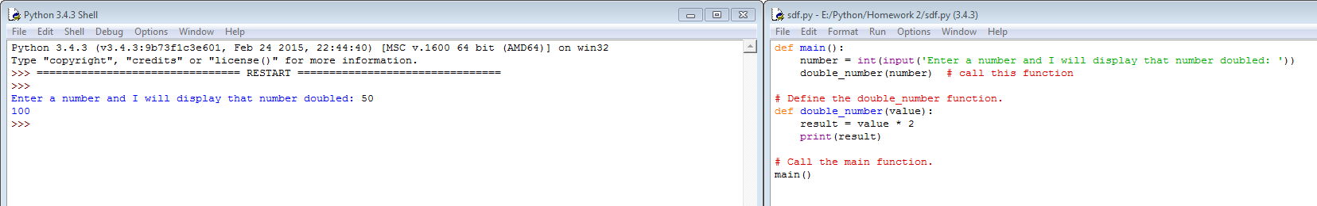

Q3: show all the sum of two values.

# This program demonstrates a function that accepts

# two arguments.

def main():

print('The sum of 12 and 45 is')

show_sum(________________________)

# The show_sum function accepts two arguments

# and displays their sum.

def show_sum(___________________, ________________________):

result = num1+ num2

print(result)

# Call the main function.

main()

Fill in the above empty place, and the debug this code. After you get this program to successfully run, capture its output and then close it.

